

Mini Project Report – 08

Master of Computer Application – General Semester – I
Sub: Frontend Frameworks and Technologies

Topic: JavaScript Grade Calculator
By
Name: Ashraj Singh Rana
Reg no.: PROV/ASAC/MCA/7/26/058

Faculty Name: VEERA RAGHAV K
Faculty Signature:

Department of Computer Application Alliance University
Chandapura - Anekal Main Road, Anekal Bengaluru - 562 106
August 2026

INDEX
FIG NO. | Name | Page No
1 | INTRODUCTION | 3
2 | INPUT CODE | 4-7
3 | OUTPUT | 8
4 | CONCLUSION | 9

INTRODUCTION
The JavaScript Grade Calculator is a web-based application designed to calculate and display a student's academic performance. The application allows the user to enter their name and marks obtained in five different subjects. Using JavaScript, the system calculates the total marks, average marks, percentage, grade, and pass or fail status automatically.
The project is developed using HTML and JavaScript. HTML is used to create the structure and input form, while JavaScript is used to perform calculations, apply grading conditions, and display the results dynamically. This project demonstrates the practical use of JavaScript concepts such as variables, functions, arithmetic operations, conditional statements, and DOM manipulation.
The main objective of this project is to provide a simple and efficient way to calculate student results while demonstrating the use of JavaScript in an interactive web application.

INPUT CODE
<!DOCTYPE html>
<html>
<head>
<title>Grade Calculator</title>
<style>
* {
box-sizing: border-box;
}

body {
margin: 0;
font-family: "Segoe UI", Tahoma, Geneva, Verdana, sans-serif;
background: linear-gradient(135deg, #0f172a 0%, #1e293b 35%, #312e81 100%);
display: flex;
justify-content: center;
align-items: center;
min-height: 100vh;
color: #e2e8f0;
}

.calculator {
background: rgba(15, 23, 42, 0.78);
border: 1px solid rgba(148, 163, 184, 0.25);
backdrop-filter: blur(12px);
padding: 30px 28px 24px;
width: min(760px, 92vw);
border-radius: 24px;
box-shadow: 0 25px 50px rgba(15, 23, 42, 0.45);
}

h2 {
margin: 0 0 24px;
text-align: center;
color: #f8fafc;
font-size: clamp(1.8rem, 3vw, 2.5rem);
letter-spacing: 0.04em;
}

.grid {
display: grid;
grid-template-columns: repeat(2, minmax(180px, 1fr));
gap: 18px 20px;
}

.subject {
background: rgba(15, 23, 42, 0.45);
border: 1px solid rgba(148, 163, 184, 0.18);
border-radius: 16px;
padding: 14px 14px 12px;
}

.subject label {
display: block;
margin-bottom: 8px;
font-weight: 700;
color: #cbd5e1;
letter-spacing: 0.04em;
}

input {
width: 100%;
padding: 12px 14px;
border: 1px solid rgba(148, 163, 184, 0.3);
border-radius: 10px;
background: rgba(15, 23, 42, 0.7);
color: #f8fafc;
font-size: 1rem;
outline: none;
transition: border-color 0.2s ease, box-shadow 0.2s ease;
}

input:focus {
border-color: #7c3aed;
box-shadow: 0 0 0 3px rgba(124, 58, 237, 0.2);
}

input::placeholder {
color: #94a3b8;
}

button {
width: 100%;
padding: 15px 18px;
margin-top: 24px;
background: linear-gradient(135deg, #7c3aed 0%, #3b82f6 100%);
color: #f8fafc;
border: none;
border-radius: 12px;
font-size: 1.05rem;
font-weight: 700;
letter-spacing: 0.04em;
cursor: pointer;
box-shadow: 0 12px 24px rgba(59, 130, 246, 0.35);
transition: transform 0.2s ease, box-shadow 0.2s ease;
}

button:hover {
transform: translateY(-1px);
box-shadow: 0 16px 28px rgba(124, 58, 237, 0.4);
}

#result {
margin-top: 22px;
min-height: 88px;
padding: 16px 18px;
border-radius: 14px;
text-align: center;
font-weight: 700;
line-height: 1.8;
color: #e2e8f0;
background: rgba(30, 41, 59, 0.75);
border: 1px solid rgba(148, 163, 184, 0.15);
}

@media (max-width: 560px) {
.calculator {
padding: 24px 18px 18px;
}

.grid {
grid-template-columns: 1fr;
}
}
</style>
</head>
<body>

<div class="calculator">
<h2>Grade Calculator</h2>

<div class="grid">
<div class="subject">
<label>FFT</label>
<input type="number" id="fft" placeholder="Enter marks">
</div>

<div class="subject">
<label>ADS</label>
<input type="number" id="ads" placeholder="Enter marks">
</div>

<div class="subject">
<label>BAD</label>
<input type="number" id="bad" placeholder="Enter marks">
</div>

<div class="subject">
<label>PST</label>
<input type="number" id="pst" placeholder="Enter marks">
</div>

<div class="subject">
<label>CLS</label>
<input type="number" id="cls" placeholder="Enter marks">
</div>

<div class="subject">
<label>AUI</label>
<input type="number" id="aui" placeholder="Enter marks">
</div>

<div class="subject">
<label>DST</label>
<input type="number" id="dst" placeholder="Enter marks">
</div>
</div>

<button onclick="calculate()">Calculate Grade</button>

<div id="result"></div>
</div>

<script>
function calculate() {
let subjects = ["fft", "ads", "bad", "pst",
"cls", "aui", "dst"];

let total = 0;

for (let subject of subjects) {
let marks = document.getElementById(subject).value;

if (marks === "" || marks < 0 || marks > 100) {
document.getElementById("result").innerHTML =
"Enter marks between 0 and 100";
return;
}

total += Number(marks);
}

let percentage = total / 7;
let grade;

if (percentage >= 90) {
grade = "A+";
} else if (percentage >= 80) {
grade = "A";
} else if (percentage >= 70) {
grade = "B";
} else if (percentage >= 60) {
grade = "C";
} else if (percentage >= 40) {
grade = "D";
} else {
grade = "F (Fail)";
}

document.getElementById("result").innerHTML =
"Total Marks: " + total + " / 700<br>" +
"Percentage: " + percentage.toFixed(2) + "%<br>" +
"Grade: " + grade;
}
</script>

</body>
</html>

Output

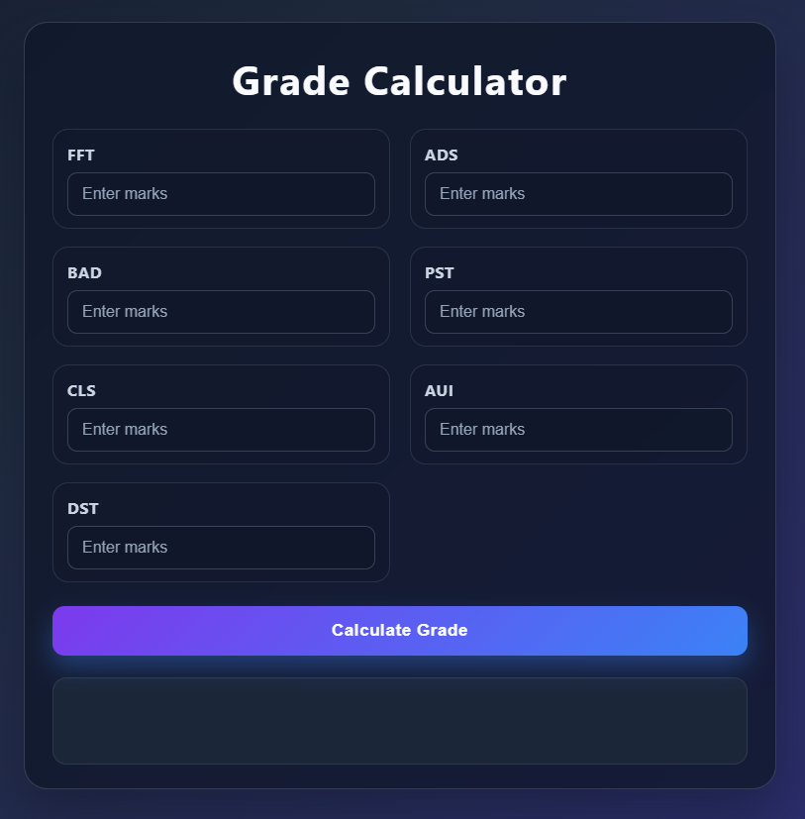

Conclusion
In conclusion, the JavaScript Grade Calculator successfully calculates the student’s total marks, average marks, percentage, grade, and pass/fail result based on the entered subject marks. This project demonstrates the practical use of HTML forms, JavaScript variables, calculations, conditions, and DOM manipulation. It provides a simple and useful way to automate the grade calculation process.

9

